The Bristol Bus Boycott

Task 1
If you have access to the internet click on the link and watch this short BBC documentary about the Bristol Bus Boycott: https://www.bbc.co.uk/news/av/uk-england-21525110/bristol-bus-boycott-50-years-on

Task 2
Answer these questions about the video

Bristol Boycotts April 1963:
1. What were the Paul and Roy motivated by?

2. Where country did Guy Bailey come from?

3. What happened when Guy Bailey went to the job interview for Omnibus?

4. Who joined the bus boycott protests?

5. What didn’t the bus company want black bus drivers?

6. What month did the bus boycott come to an end?

Task 3
Read through the information about The Bristol Bus Boycott
Why did the bus boycott happen?
On April 30, 1963, Bristol’s black population protested against The Bristol Omnibus Company and the Transportation and General Workers’ Union (TGWU) racist employment practices, because unlike hiring black bus drivers like in cities such as Bath and London, Bristol was slow to hire them and actually refused to.
The TGWU’s failure to address its discriminatory hiring policy also influenced a 1955 vote that prohibited black bus drivers.
Although black people were part of the TGWU, they were primarily forced to work in fixing/cleaning the buses and working in the canteens.
Moreover, by 1958 the black unemployment rate was twice the reported figure of white unemployment in Bristol. Something had to change.

Change is coming!
Paul Stephenson, who was born in Essex, England to West African and British parents, Bristol’s first black social worker and an ex-Royal Air Foreman, explored exposing the Omnibus Company’s discriminatory practices.
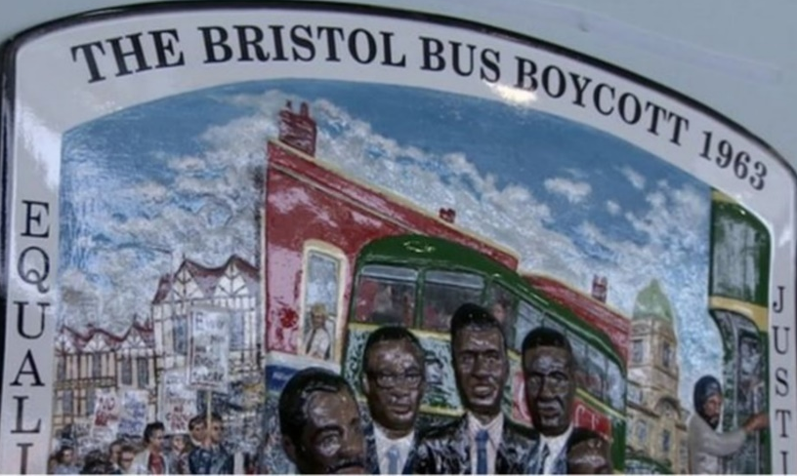
Four young West Indian men, Roy Hackett, Owen Henry, Audley Evans and Prince Brown, formed an action group.
They were unhappy with the lack of progress in fighting discrimination by the West Indian Association.

The group decided that the articulate Stephenson would be their spokesman.
Stephenson had been teaching night classes at the time and knowledgeable of the 1955-1956 Montgomery Bus Boycott in the United States, Stephenson recruited one of best pupils, 18-year-old Guy Bailey, and together decided to respond to a vacant bus conductor employment advertisement in the Bristol’s Evening Post.
At his interview, the bus manager told Bailey, “We do not hire black people.” To confirm this, Stephenson went to the Company’s General Manager, Ian Patey, who affirmed the Omnibus Company’s practices.
Roy Hackett, Owen Henry, Audley Evans and Prince Brown formed the West Indian Development Council, a coalition to challenge and expose the Omnibus Company’s racist policy.
On April 29, 1963, the coalition announced that no blacks would ride the bus the subsequent day. The April 30 bus boycott garnered national support and disapproval.

What happened and who supported the movement?
- Bristol University students who supported the boycott were harassed and attacked in public.
- They marched earnestly, however, with placards stating, “EVERY MAN HAS THE RIGHT TO WORK.”
- Local Labour MP Tony Benn remarked, “I shall stay off the buses, even if I have to find a bike!”
- Famous Trinidadian cricketer Sir Learie Constantine wrote letters to the Omnibus Company in support of the boycott.
- The boycott gathered supported from whites, politicians and sportsmen. This made the protest even more popular.
Opposition to the movement:
- Oppositional newspaper headlines such as, “Bristol Bus Crew Back the Boss” and “We Won’t Work with West Indians,” further underscored how divisive the bus boycott was on race.
What was the result?
- After months of boycotting, the TGWU in a meeting with 500 bus workers agreed on August 27, 1963 to end the colour bar, and Patey publicly announced it “dead” the next day.
- On September 17, Raghibir Singh, a British-Asian Sikh, became Bristol’s first non-white bus conductor. Soon afterwards Black bus crews were then hired.
- The hiring of non-white bus crews, however, did not end discrimination and racism in workspaces and in buses.
- In 1965, the government passed Race Relations Act made “racial discrimination unlawful in public places,” and the 1968 Race Relations Act made racial housing and employment practices illegal.
- In 2009, Bailey, Hackett and Stephenson were individually awarded the prestigious Order of the British Empire (OBE) medal for organizing the Bristol Bus Boycott.
- After the TWGU merged with the Unite Union in 2007, they issued an apology in February 2013 for their role in obstructing the hiring of black bus workers in Bristol in 1963.

Task 4:
Read through and answer the following questions using full sentences.
- What problem did the West Indian Association try to solve and why?

- What was the outcome of the Bristol Boycott

- Create a short speech for one of the members of the West Indian Association, trying to persuade public to support their protest in 1963. What key things could you include to make to persuade them? Why would some black/white people be scared to join the protests?

