art@stmatthias
- The definition of identity is who you are, the way you think about yourself, the way you are viewed by the world and the characteristics that define you.

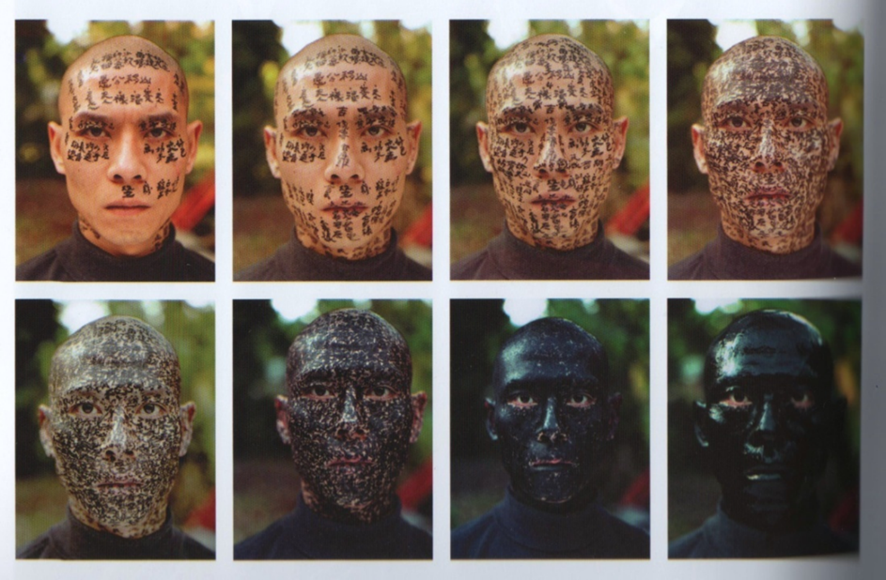
Zhang Huen is an artist inspired by his cultural identity.
For ‘Family Tree’ he has his face covered in writing from a traditional chinese tale. ‘I cannot tell who I am, my identity has disappeared’

IDENTITY Research
Name of artist_Zhang Huen
What medium does the artist use?e.g. oil paint/clay/pencil/mixed media/digital art etc.

What do you like/dislike about the art?

Why did the artist created it? What was he trying to say?

What do you like/dislike about his work?

How does the artwork make you feel and why? What’s the mood and how does he create it?

What are your top 5 words to describe the work of this artist?

What visual ELEMENTS are in the artwork?
Line shape form tone pattern colour texture

Use the internet to find out 5 facts about the artist.

Task 3. Inspired by Zhang Huen, draw a basic

SELF PORTRAIT (drawing of you self) and use the words from your mind map to write over it/behind it.
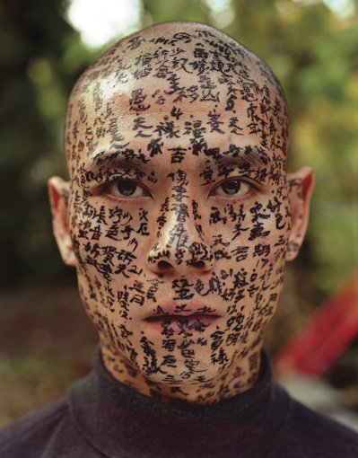
You can use the following outline or draw your own from observation (look in a mirror).
