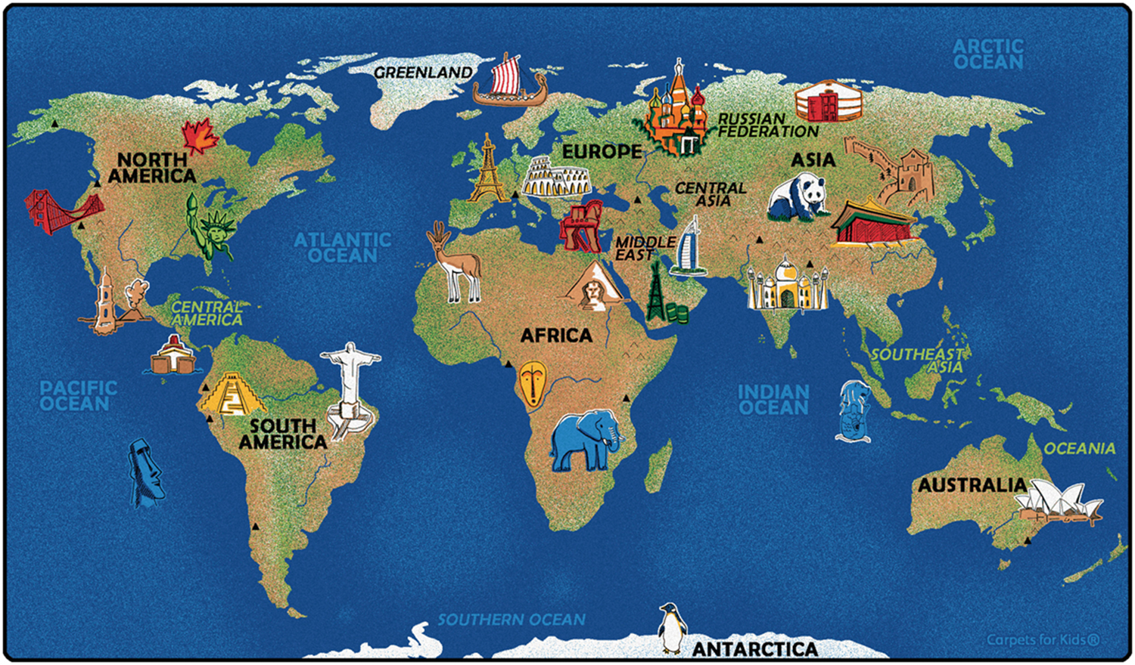
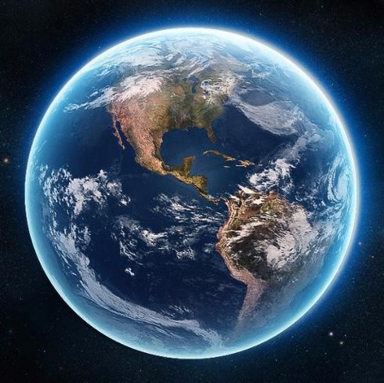
Natural Wonders of the World
- Art@stmatthias
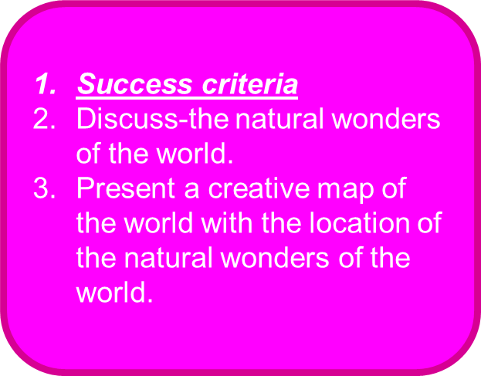
- Grand Canyon — North America​

- Great Barrier Reef — Oceania/Australia​

- Harbor of Rio de Janeiro — South America​

- Mount Everest — Asia​

- Aurora — North America​

- Parícutin Volcano — South America​

- Victoria Falls — Africa

- TASK 1 Using the internet, research and record facts on each of the 7 Natural Wonders of the World
Paricutin Volcano

Victoria Falls

Harbour of Rio de Janerio

Grand Canyon

Aurora

Mount Everest

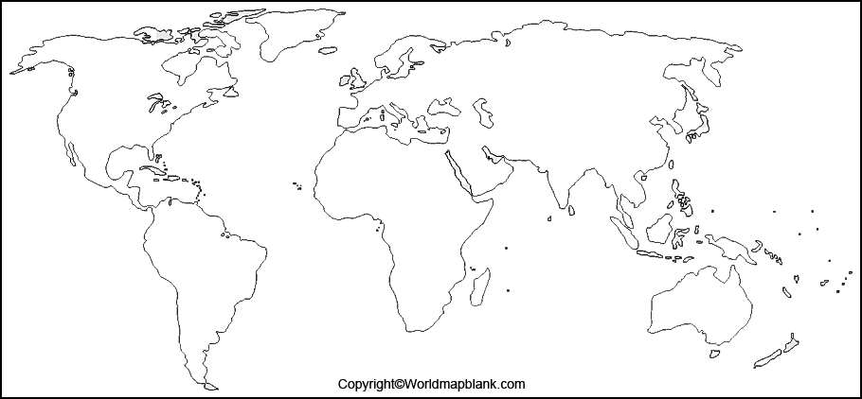
TASK
- Label where all the Natural Wonders of the World are on the world map ( you will need to use the internet to research this)
- Add colour using medium of choice.
- CHALLENGE TASK: draw the map and add colour, label the Natural Wonders with drawings.

