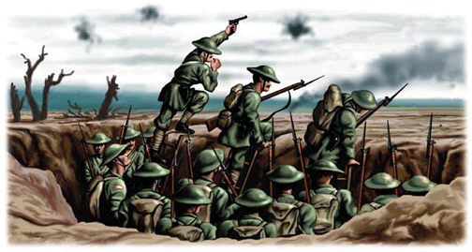**Trench conditions: What was trench warfare like?**

Name: ____________________

Class: VENUS

**Task One:**

Using the letters that make up the words **Trench Warfare** see how many words that you can create. Add your words to the table below:

|  |  |  |  |
| --- | --- | --- | --- |
| 1. Trench | 2. Warfare | 3. | 4. |
| 5. | 6. | 7. | 8. |
| 9. | 10. | 11. | 12 |
| 13. | 14. | 15. | 16. |
| 17. | 18. | 19. | 20. |
| 21. | 22. | 23. | 24. |
| 25. | 26. | 27. | 28. |
| 29. | 30. | 31. | 32. |
| 33. | 34. | 35. | 36. |
| 37. | 38. | 39. | 40. |
| 41. | 42. | 43. | 44. |
| 45. | 46. | 47. | 48. |
| 49. | 50. | 51. | 52. |
| 53. | 54. | 55. | 56. |
| 57. | 58. | 59 | 60. |

**Task 2**

Draw a simple line drawing/diagram of a typical battlefield during the Great War and label it. Use this picture and the keywords to help you

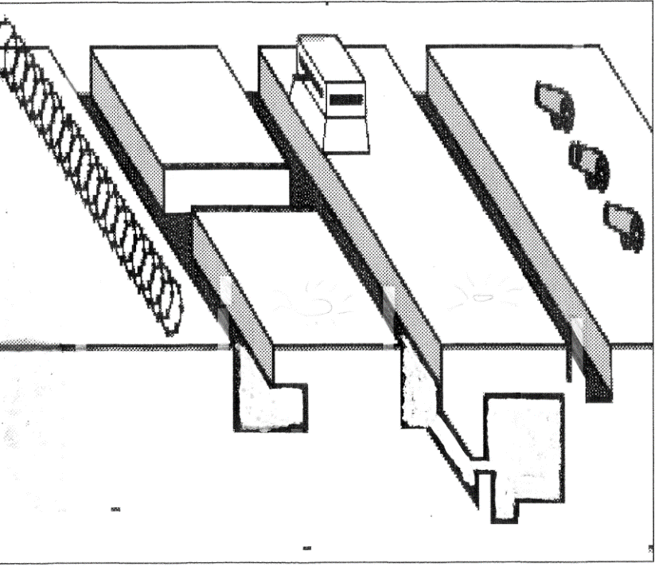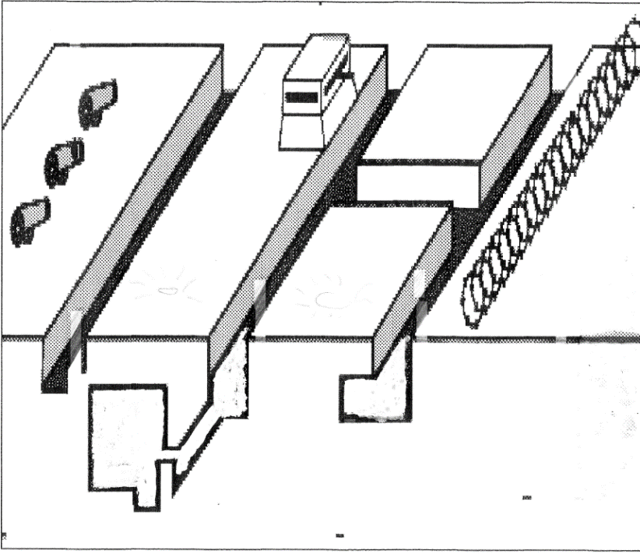

Your diagram will need to be labelled with the following:

No Mans Land; Barbed Wire; Artillery/Howitzers; British Trench; German Trench; Mud filled Shell holes/Craters; Clouds of poison gas; Exploding shells; Machine gun tower; Basic Dug Out; Underground bunker.

**Task 3**: label tidily the following picture of inside A typical Great War trench.

Use this link to help you: <https://www.bbc.co.uk/bitesize/topics/zqhyb9q/articles/z8sssbk>

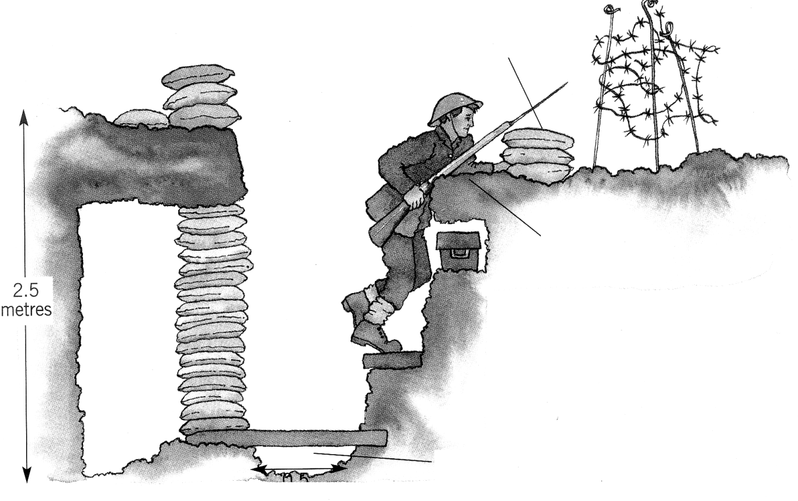

Your next task is to research into conditions facing the average soldier in the trenches.

Use BBC Bitesize (<https://www.bbc.co.uk/bitesize/topics/zqhyb9q/articles/z8sssbk>) and other websites to help you research the following aspects of life in the trenches:

Conditions

_______________________________________________________________________________________________________________________________________________________________________________________________________________________________________

Disease

_______________________________________________________________________________________________________________________________________________________________________________________________________________________________________

Food

_______________________________________________________________________________________________________________________________________________________________________________________________________________________________________

Duties

_______________________________________________________________________________________________________________________________________________________________________________________________________________________________________

Fears

_______________________________________________________________________________________________________________________________________________________________________________________________________________________________________

How are each of these pictures linked to trench conditions?

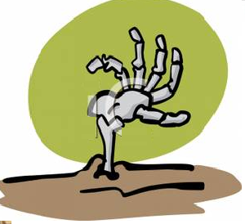

_______________________________________________________________________________________________________________________________________________________________________________________________________________________________________



_______________________________________________________________________________________________________________________________________________________________________________________________________________________________________

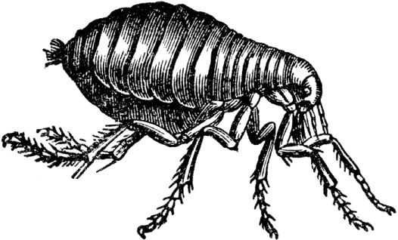

_______________________________________________________________________________________________________________________________________________________________________________________________________________________________________

http://www.clipartguide.com/_thumbs/0511-1007-1912-0861.jpg_______________________________________________________________________________________________________________________________________________________________________________________________________________________________________



_______________________________________________________________________________________________________________________________________________________________________________________________________________________________________

How are the sources presenting life in the trenches?

Tell me your opinion and give examples from the sources

**Source A - Sergeant A. Vine, diary entry, 8th August, 1915**

**Source B - 'The Harvest of Battle', by CRW Nevinson in 1919**

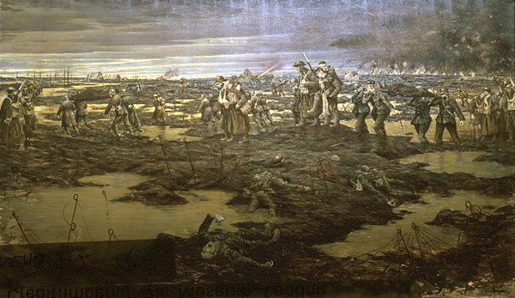

*The stench of the dead bodies now is awful as they have been exposed to the sun for several days, many have swollen and burst. The trench is full of other occupants, things with lots of legs, also swarms of rats.*

______________________________________________________________________________________________________________________________________________________________________________________________________________________________________________________________________________________________________________________________________________________________________________________________________________________________________________________________________________

_______________________________________________________________________________________________________________________________________________________________________________________________________________________________________

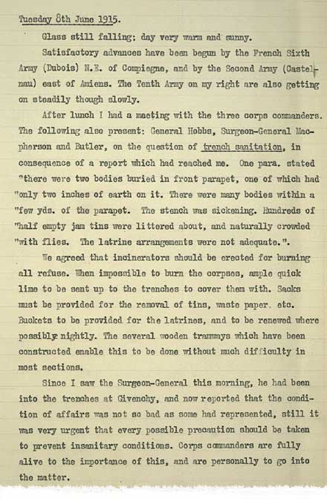

**Source C - Extract from General Haig's war diaries, June 1915**

Make a list of all the bad things Haig is mentioning in his letter.



Use a dictionary to help you to complete the definition

Censorship is…

__________________________________________________________________________________________________________________________________________________________

Censor the two letters to make sure that people back home know the soldiers are having a good time! Scribble out the negative sentences. (Negative is anything that is bad.)





Why do you think the government censored letter?

______________________________________________________________________________________________________________________________________________________________________________________________________________________________________________________________________________________________________________________________________________________________________________________________________________________________________________________________________________

Write a letter home to your parents or loved one explaining the horrors of trench warfare. Make sure you include: **What were conditions like in the trenches?** **What was the morale of your fellow soldiers? How do you feel about going ‘over the top’?** **Describe in detail your emotions: fear, desperation, helplessness etc.**

______________________________________________________________________________________________________________________________________________________________________________________________________________________________________________________________________________________________________________________________________________________________________________________________________________________________________________________________________________

____________________________________________________________________________________________________________________________________________________________________________________________________________________________________________________________________________________________________________________

Attacking a Trench

Do some research on each of these weapons and come up with some advantages and disadvantages.

|  |  |  |  |
| --- | --- | --- | --- |
| **Weapon** | **Advantages**  Good thing about this weapon. | **Disadvantages**  Bad thing about this weapon. | **Cost** |
| Artillery (Shells)  http://www.landscaper.net/images/ww1coast.jpg |  |  | **£250 each** |
| Zeppelin  http://letchworthinthegreatwar.wikispaces.com/file/view/zeppelin.jpg/246104329/zeppelin.jpg | Very quiet, so can’t be heard coming. | Expensive! | **£2,000** |
| Flamethrowers |  |  | **£65 each** |
| Tanks |  | Expensive! | **£1,500** |
| Grenades |  |  | **£5 each** |
| Machine Guns |  |  | **£175 each** |
| Gas  http://upload.wikimedia.org/wikipedia/commons/6/69/US_WWI_Gas_mask_with_bag.JPG | If you don’t have a gas mask it can either blind you or kill you. |  | **£15 per canister** |
| Plane  http://3219a2.medialib.glogster.com/media/74/74916439269cac748a734ca28d766aa1ea800f482d68815c81ab820e25df7f54/plane-jpg.jpg |  | Expensive! | **£1,750** |

Which weapon would have been the best and why?

__________________________________________________________________________________________________________________________________________________________

____________________________________________________________________________________________________________________________________________________________________________________________________________________________________________________________________________________________________________________

Bring in the TANKS!

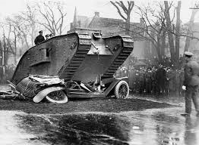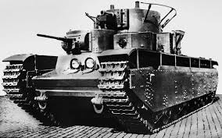**World War One Trench Warfare**

**Words**

Numbers Bulletproof Origins Prototype

Barbed Wire Machine Gun Secret Twentieth

Terrain Warfare

Tanks have played a large role in land ______ during the _______ century. The ______ of the tank can be found in the First World War. The war was being dominated by the ___________, and this, combined with _________ on the battlefield was creating a stalemate situation with troops unable to move forward. The British Army started to develop a ___________ machine able to move over obstacles with ease using caterpillar tracks. The first _______ was tested in February 1916. It was a success and the army started the ______ manufacture of this weapon. If tanks were to be effectively used in the war, then they had to be used in large ______ and on suitable _______.

## **Key Facts & Information**

### **PHYSICAL FEATURES**

* The Western Front in World War I, located in [France](https://kidskonnect.com/places/france/), was fought using trench warfare. [WWI started on 28 June 1914](https://kidskonnect.com/history/ww1-start/), and by the end of 1914, both sides had built trenches that went from the North Sea and through Belgium and France. Neither side made much ground for nearly three and a half years – from October 1914 to March of 1918.
* It is estimated that there were about 2,490 kilometre of trench lines dug during World War I. Most trenches were between 1-2 metres wide and 3 metres deep.
* Trenches weren’t dug in straight lines. The WWI trenches were built as a system, in a zigzag pattern with many different levels along the lines. They had paths dug so that soldiers could move between the levels.
* Trenches typically had an embankment at the top and a barbed wire fence. Often, trenches in World War I would be reinforced with sandbags and wooden beams. In the trench itself, the bottom was covered with wooden boards called duckboards. These were meant to protect the soldiers’ feet from the water in the trenches to try and prevent Trench Foot.
* The trenches were dug by soldiers and there were three ways to dig them. Sometimes the soldiers would simply dig the trenches straight into the ground – a method known as entrenching. Entrenching was fast, but the soldiers were open to enemy fire while they dug. Another method was to extend a trench on one end. It was called sapping and was a safer method but took a lot longer. Tunneling – which is digging a tunnel and then removing the roof to make a trench when it is complete – was the safest method, but it was the most difficult too.
* Trenches needed to be repaired constantly to prevent erosion from the weather and from enemy bombs and gunfire.
* It took 450 men six hours to build around 250 metres of British trenches.

### **LIFE IN THE TRENCHES**

* Life in the trenches was very difficult because they were dirty and flooded in bad weather. Many of the trenches also had pests living in them, including rats, lice, and frogs. Rats in particular were a problem and ate soldier’s food as well as the actual soldiers while they slept.
* Lice also caused a disease called Trench Fever that made the soldiers’ itch terribly and caused fever, headache, sore muscles, bones, and joints.
* Many soldiers living in the trenches suffered from Trench Foot. Rain and bad weather would flood the trenches making them boggy, muddy, and could even block weapons and make it hard to move in battle.
* Sustained exposure to the wet, muddy conditions could cause Trench Foot, which sometimes would result in the foot being amputated. Cold weather was dangerous too, and soldiers often lost fingers or toes to frostbite.
* Some soldiers also died from exposure in the cold.
* Soldiers rotated through three stages of the frontline. Most soldiers would spend anywhere from one day up to two weeks in the trenches at a time. They spent some time in the frontline trenches, time in the support trenches, and also time resting.
* Even when they weren’t fighting, soldiers had work to do – including repairing the trenches, moving supplies, cleaning weapons, undergoing inspections, or guard duty.
* The land between the two enemy trench lines was called “No Man’s Land.” No Man’s Land was sometimes covered with land mines and barbed wire. The distance between enemy trenches was anywhere from 50 to 250 yards apart.
* The noise and uncomfortable surroundings made it very difficult to sleep in the trenches. Soldiers were constantly tired and in danger of falling asleep. This is why the watch shift was kept to 2 hours to avoid men falling asleep while on watch.
* There were several cease fires or truces in the trenches during World War I. In 1914, around Christmas time, both the British and German soldiers put down their weapons, came out of their trenches and exchanged gifts and sang carols – ceasing fire to celebrate [Christmas](https://kidskonnect.com/holidays-seasons/christmas/). This is now known as the Christmas Truce.
* The majority of raids in WWI happened at night when soldiers would sneak across No Man’s Land, dodging mines, to attack the enemy in the darkness.
* Every morning, soldiers would “stand to“. This is when they stand up and prepare for battle, because many attacks would take place first thing in the morning.
* A typical WWI soldier would have a rifle, bayonet, and a hand grenade with them while fighting in the trenches.