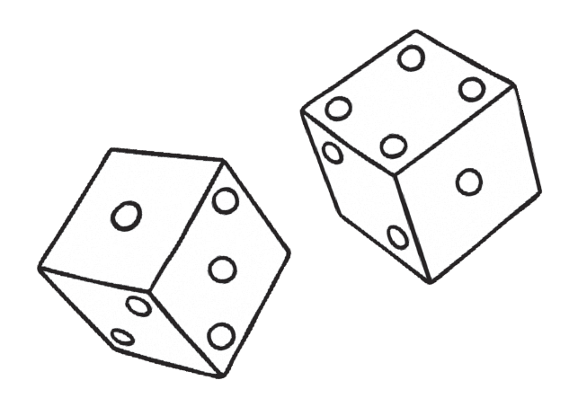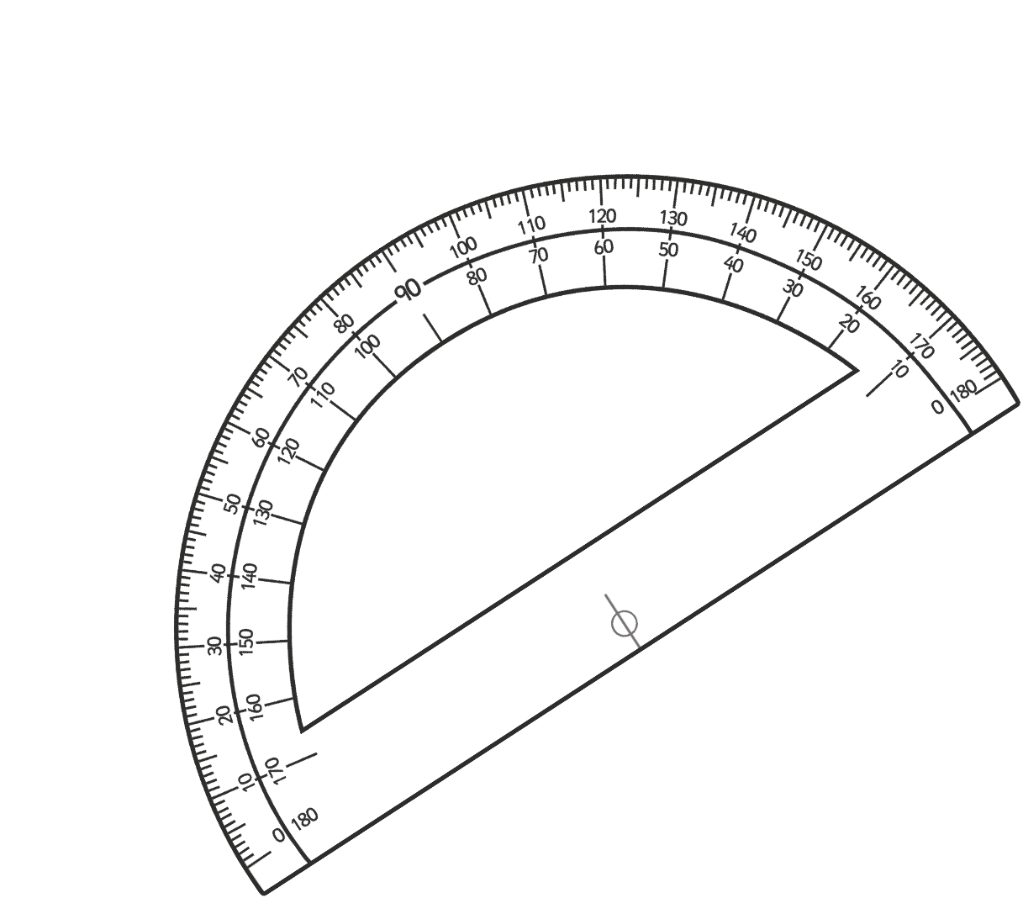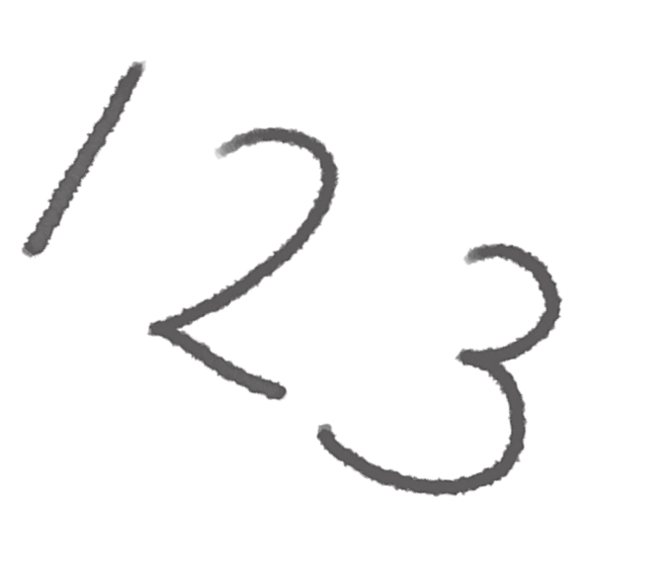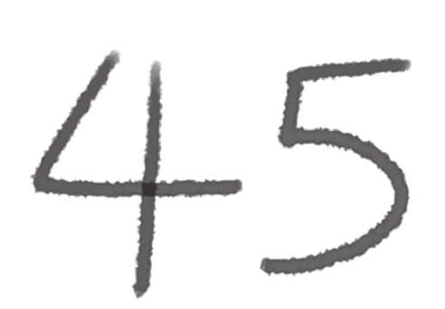

**Number Partitioning**

1.

+

+

+

+

+

1

2

=

2.

+

+

+

+

8

5

=

3.

+

+

+

+

+

2

3

=

4.

+

+

+

+

4

3

=

5.

500 000

+

+

+

+

10

=

6.

400 000

+

+

+

+

+

4

=

7.

800 000

+

+

+

+

8

=

8.

100 000

+

+

+

+

+

7

=

9.

+

+

+

+

+

7

9

=

700 000

Page 3 of 28

20

8000

2

8

4

2

90

400

1000

10 000

20

300

6000

80

400

3000

70 000

600

3000

60 000

0

3

6

2

6

4

7

8

2

7

0

4

5

6

8

9





**Ordering Numbers to 10 000**

Fill in the spaces below with the numbers in order from smallest to largest.

**2212**

**2012**

**1201**

**1022**

**2120**

**7676**

**6776**

**6677**

**7767**

**7776**

**4849**

**4948**

**4489**

**4994**

**449**

**1161**

**6161**

**1616**

**6611**

**6616**

**7220**

**2770**

**770**

**720**

**2707**

**visit twinkl.com**

Page 4 of 28





**Ordering Numbers to 100 000**

Fill in the spaces below with the numbers in order from smallest to largest.

**35 435**

**34 534**

**35 533**

**34 453**

**34 543**

**89 998**

**89 989**

**88 988**

**88 899**

**89 899**

**17 717**

**7771**

**7177**

**77 717**

**71 717**

**25 645**

**26 255**

**25 562**

**24 654**

**25 622**

**4091**

**491**

**4901**

**914**

**9410**

**visit twinkl.com**

Page 5 of 28





**Ordering Numbers to 1 000 000**

Fill in the spaces below with the numbers in order from smallest to largest.

**245 452**

**254 245**

**45 254**

**452 524**

**54 542**

**90 900**

**909 009**

**999 909**

**990 009**

**99 900**

**368 863**

**683 836**

**683 863**

**836 368**

**386 386**

**725 500**

**527 700**

**77 500**

**55 200**

**725 700**

**110 001**

**111 010**

**11 110**

**111 101**

**110 100**

**visit twinkl.com**

Page 6 of 28

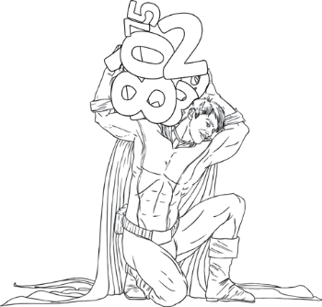

**Writing Numbers to 1 000 000 in Words**

Write the following words in numbers:

**visit twinkl.com**

Page 7 of 28

23 443

Twenty-three thousand, four hundred and forty-three

51 623

78 785

33 091

60 696

402 341

589 130

645 099

840 781

709 118

112 098

245 590

390 519

101 010



**Writing Numbers to 1 000 000 in Numbers**

Write the following words in numbers:

**visit twinkl.com**

Page 8 f 28

Two hundred and forty-five thousand, eight hundred and forty-six

245 846

Six hundred thousand, seven hundred and thirty-two

Nine hundred and thirteen thousand, five hundred and forty-one

Seven hundred and fifteen thousand, two hundred and twenty-eight

Four hundred and six thousand, seven hundred and ninety-four

Nine hundred and thirty-six thousand, two hundred and fifty-five

One hundred and seventeen thousand and four

Five hundred and thirty-five thousand, seven hundred and six

Two hundred thousand and twenty-two

Four hundred and eighty-eight thousand and sixty

Eight hundred and forty-eight thousand, nine hundred and three

Nine hundred and ninety-one thousand, one hundred and nineteen

One hundred and ninety-nine thousand, nine hundred and nineteen

Five hundred and fifteen thousand, one hundred and fifty-one